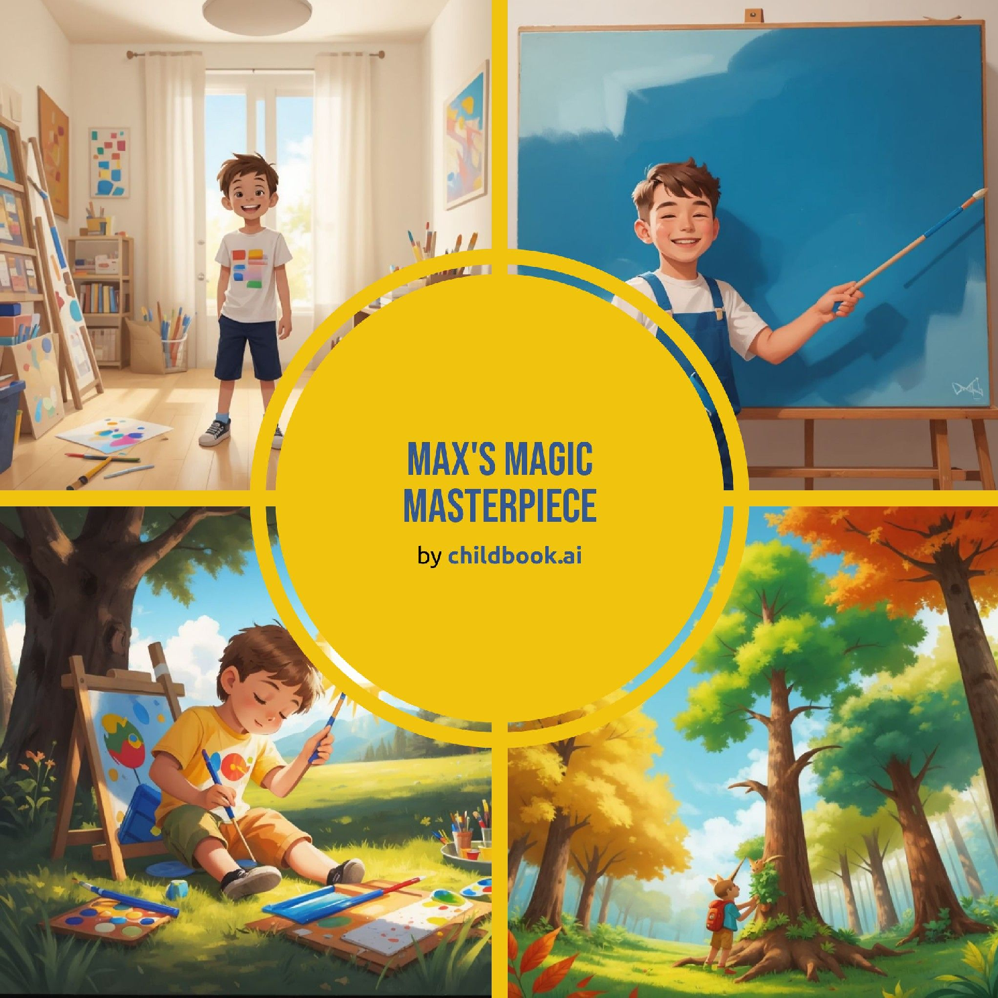

Max was a little boy who loved to draw. One sunny morning, he found a big blank canvas in his room. Max decided he would create his best painting yet. He gathered all his paints, brushes, and crayons. He was ready to start his masterpiece.

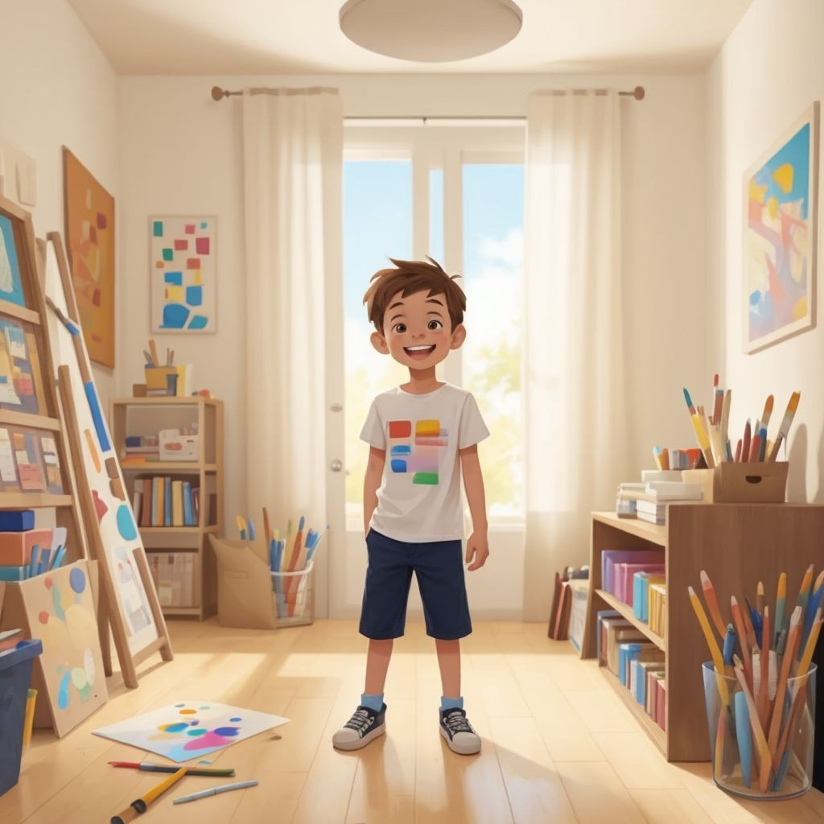

Max dipped his brush into the blue paint. He made a big, bold stroke across the canvas. It looked like the sky on a clear day. Max smiled and felt excited. He couldn't wait to add more colors.

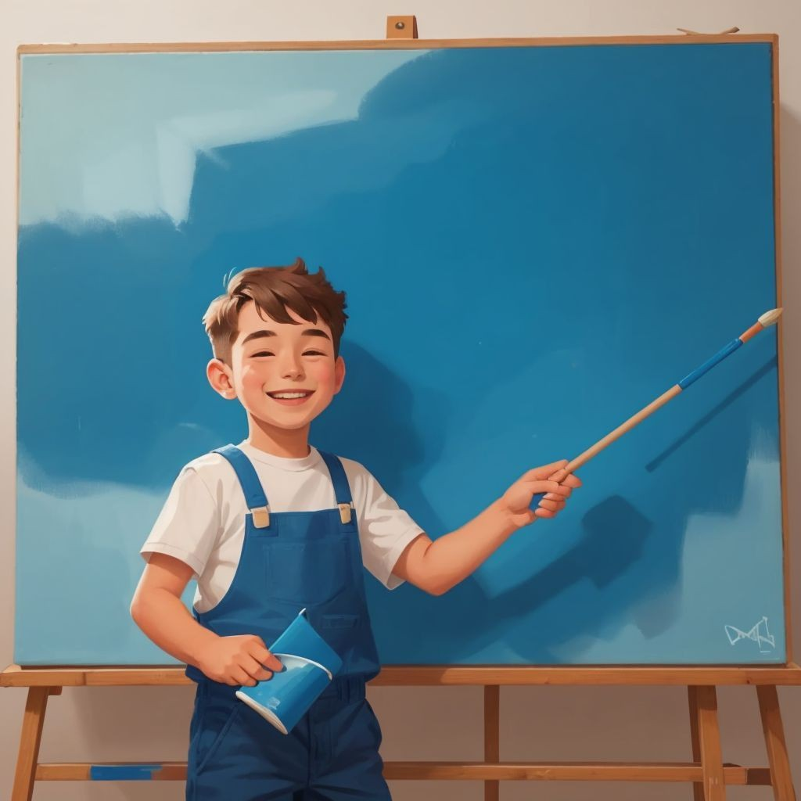

Next, Max picked up the red paint. He painted a bright, shiny sun in the corner of the canvas. Then he added green grass at the bottom. The painting was starting to look beautiful. Max felt very proud of his work.

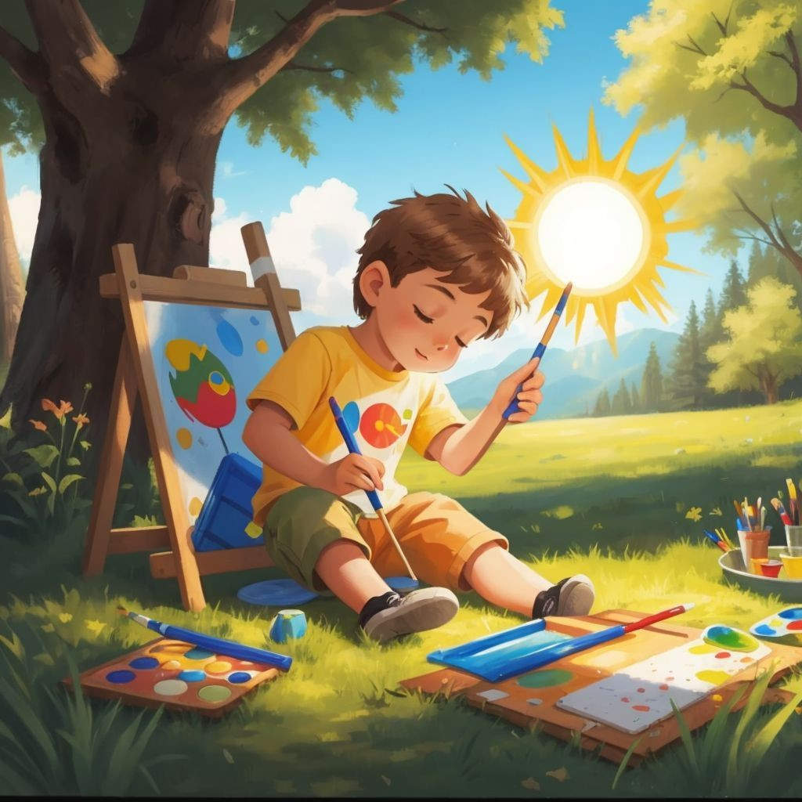

Max wanted to make his painting even more special. He closed his eyes and imagined a magical forest. He painted tall trees with colorful leaves. He even added some friendly animals. The canvas seemed to come to life.

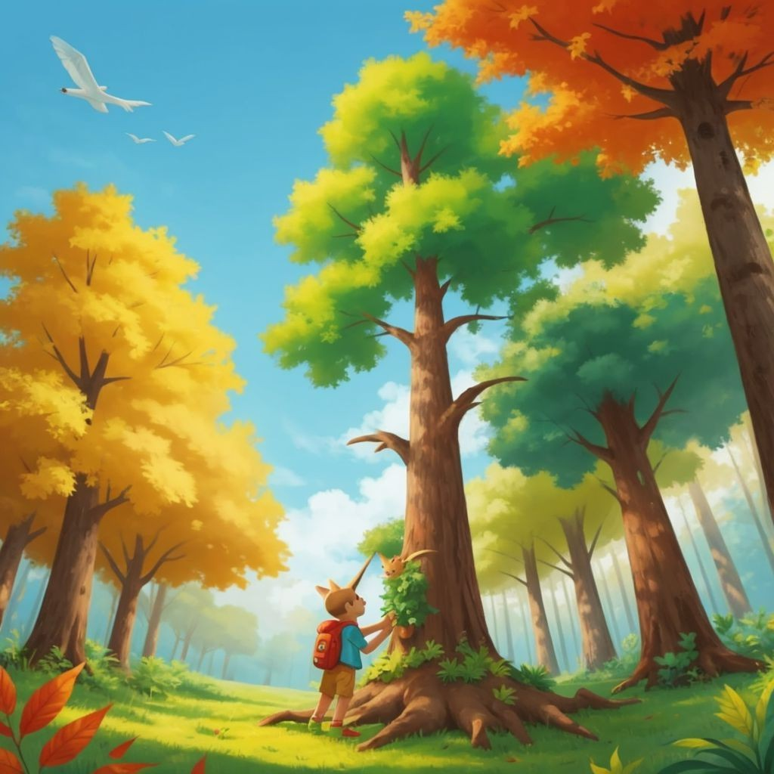

Max's mom came into the room. She saw the painting and was amazed. 'This is beautiful, Max!' she said. Max felt happy and asked his mom for some ideas. Together, they decided to add a sparkling river.

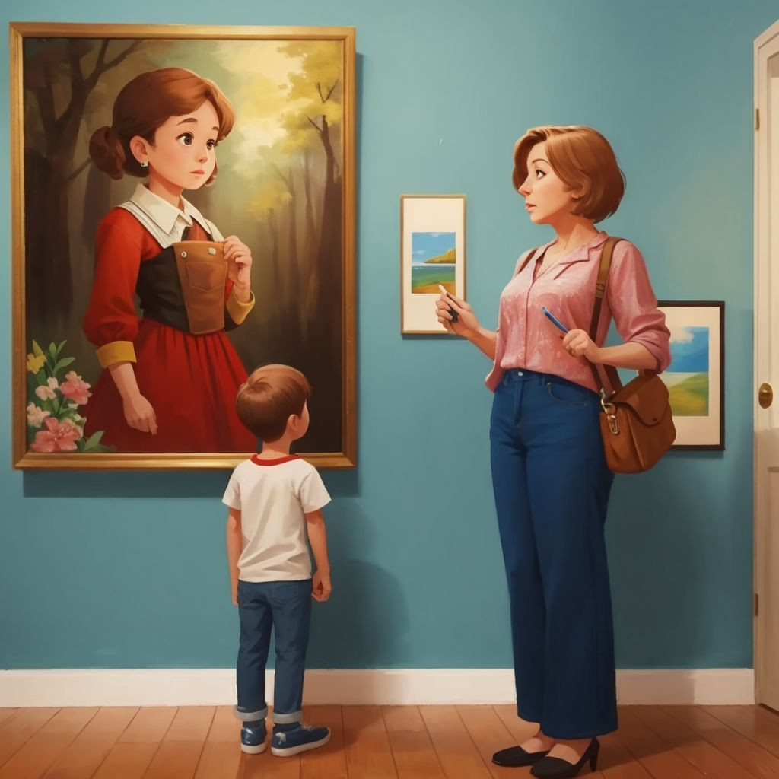

Max carefully painted the river with shimmering blue paint. He added some fish swimming in it. Then he painted a rainbow in the sky. The painting was almost complete. Max felt it was his best work ever.

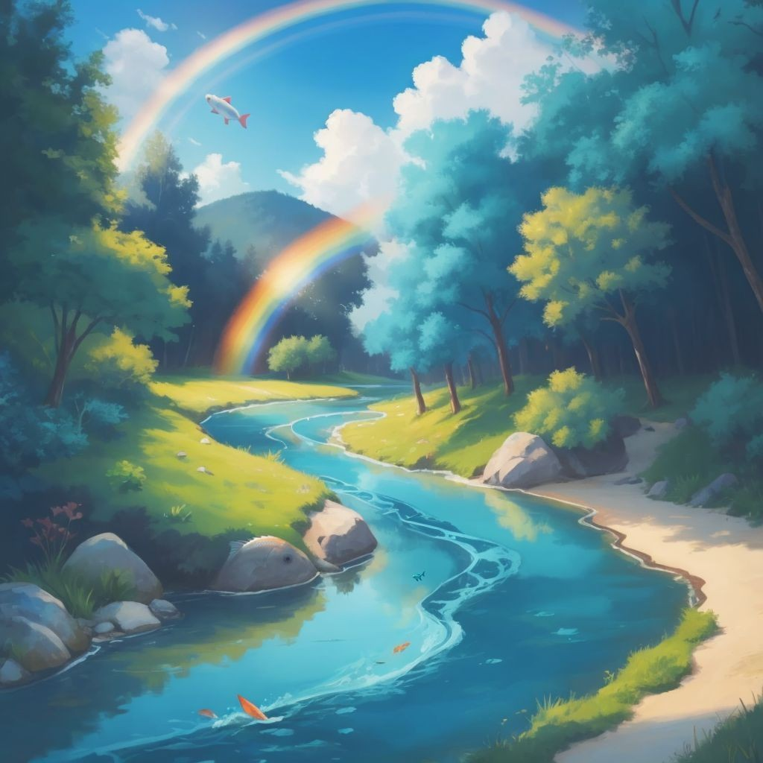

Max invited his friends to see his masterpiece. Everyone gathered around the canvas. They were all amazed by the beautiful painting. Max's friends clapped and cheered. Max felt very proud and happy.

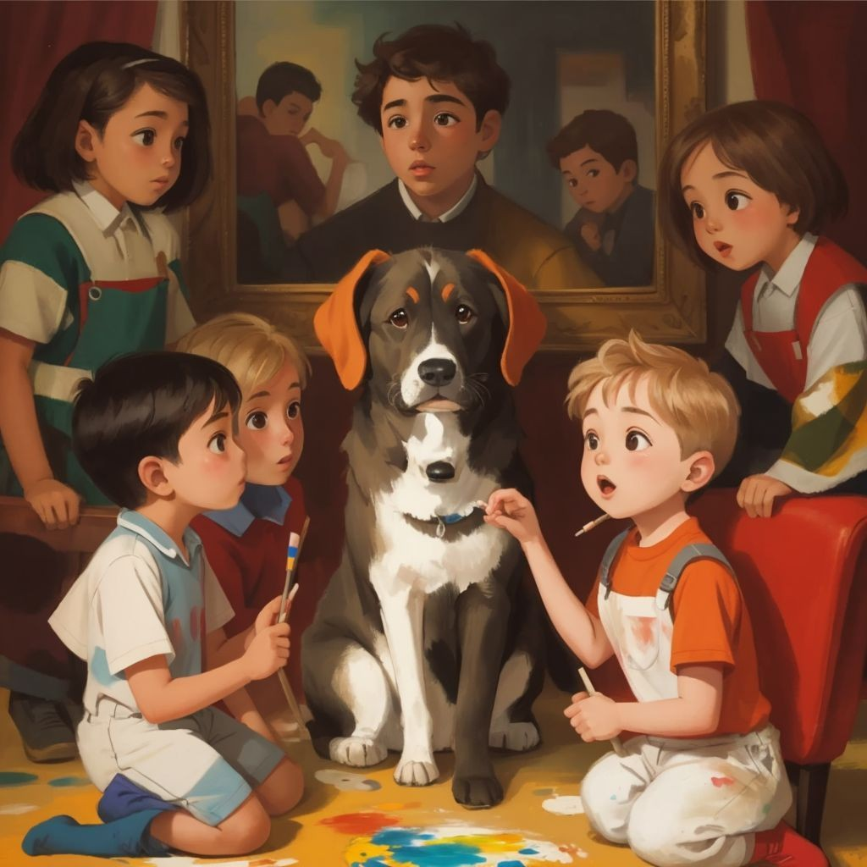

Max's painting was displayed in his room. Every time he looked at it, he felt proud. He knew he could create anything with imagination and hard work. Max decided he would keep painting and make more masterpieces. And so, Max's magical journey as an artist began.

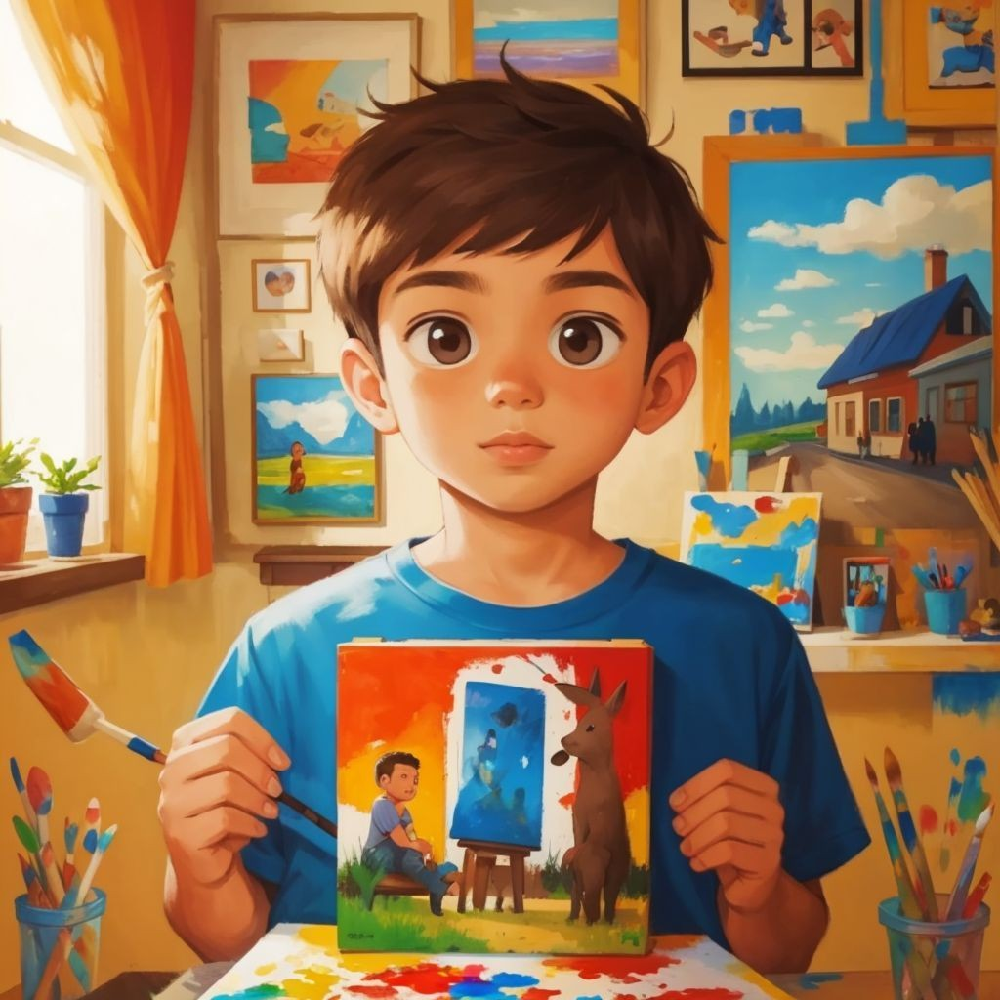

SPARK YOUR CHILD's IMAGINATION

AND CREATE PERsONALIZED CHILDREN's BOOKs WITH CHILDBOOK.AI!

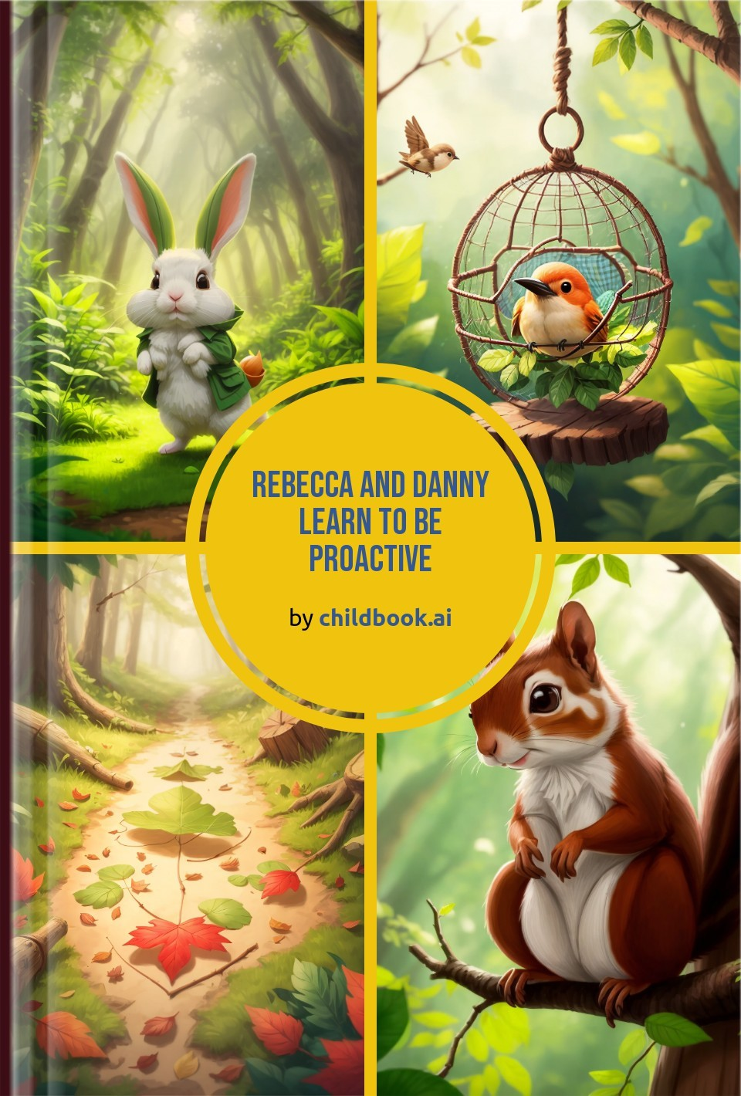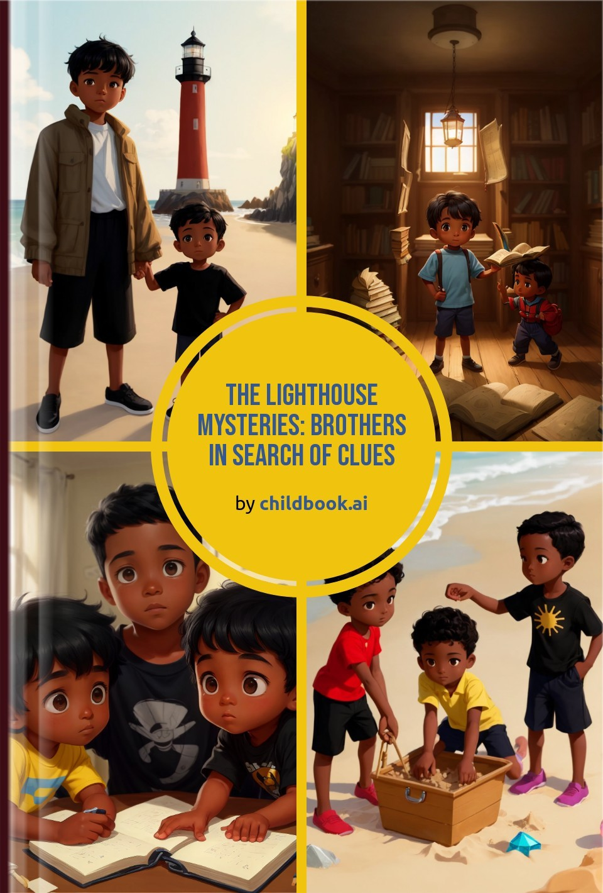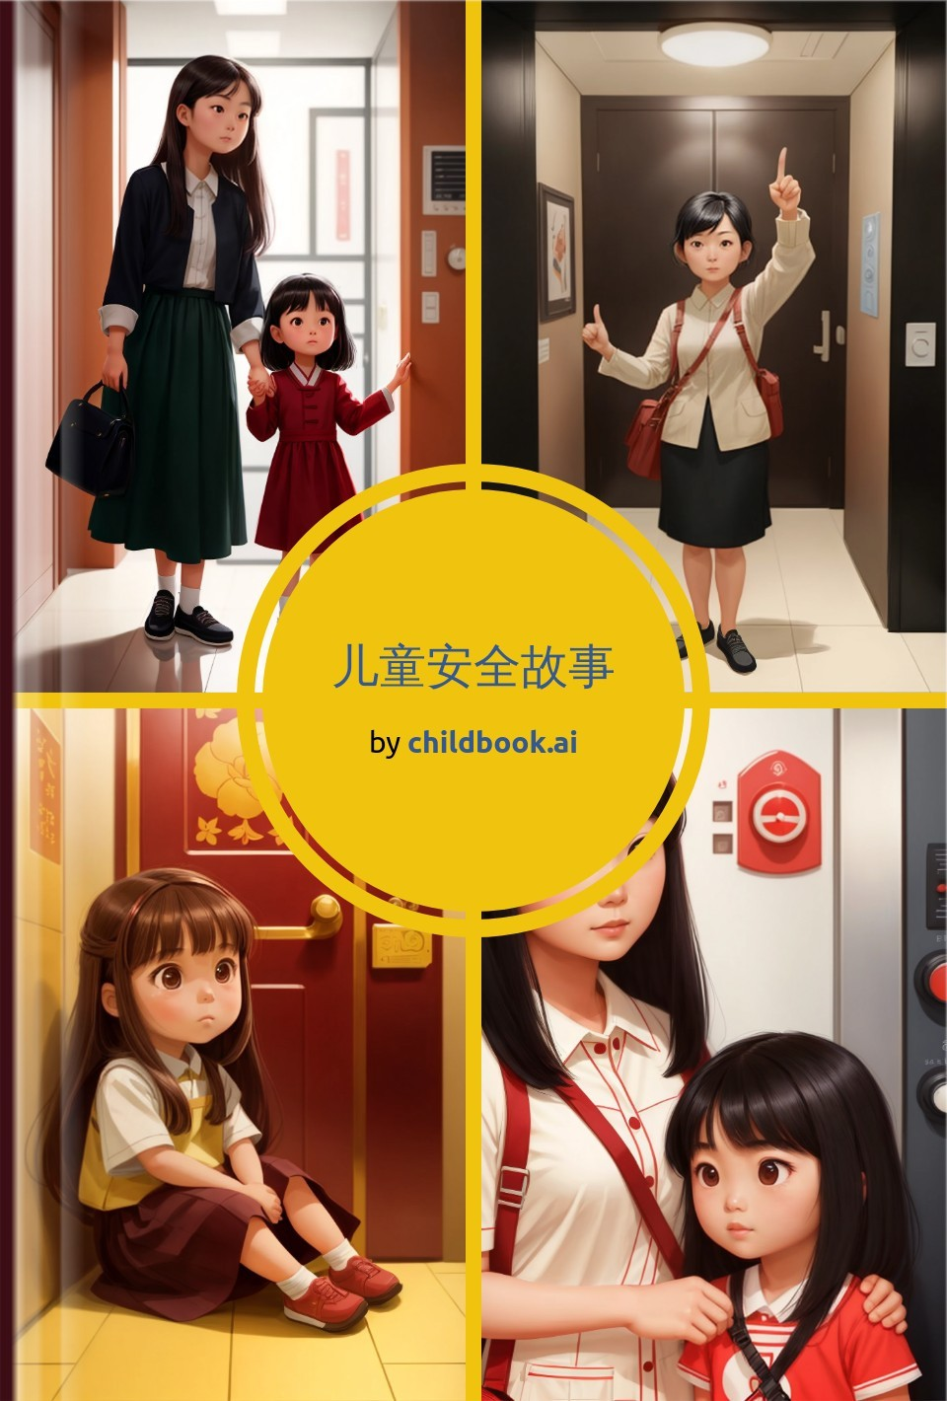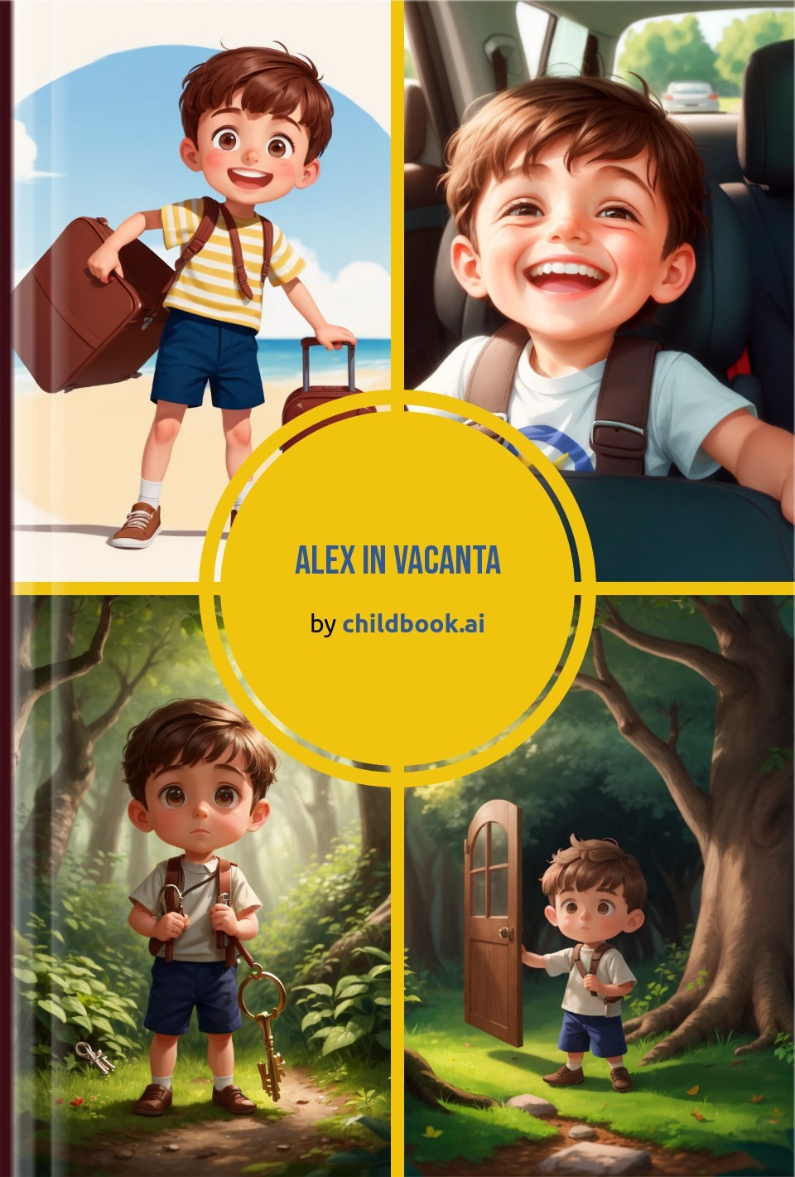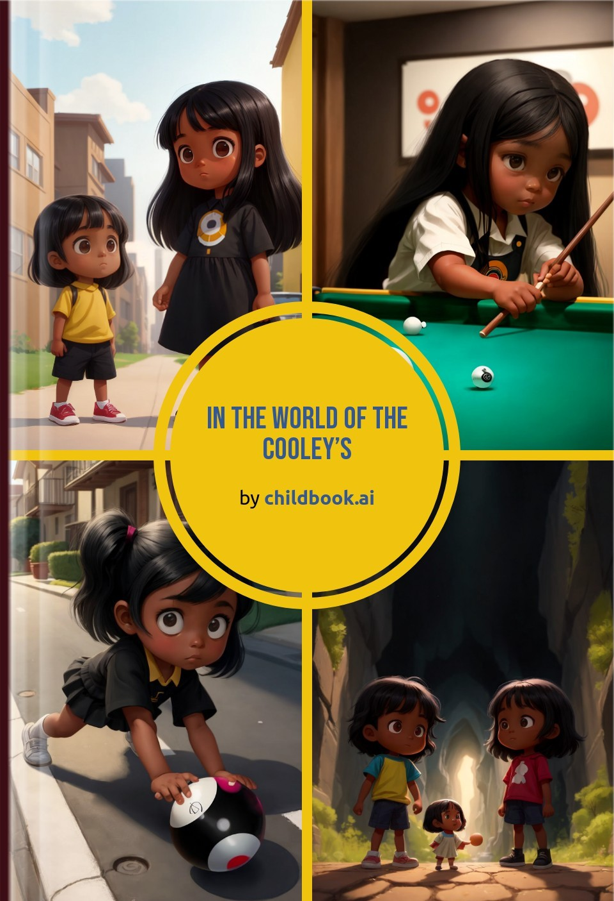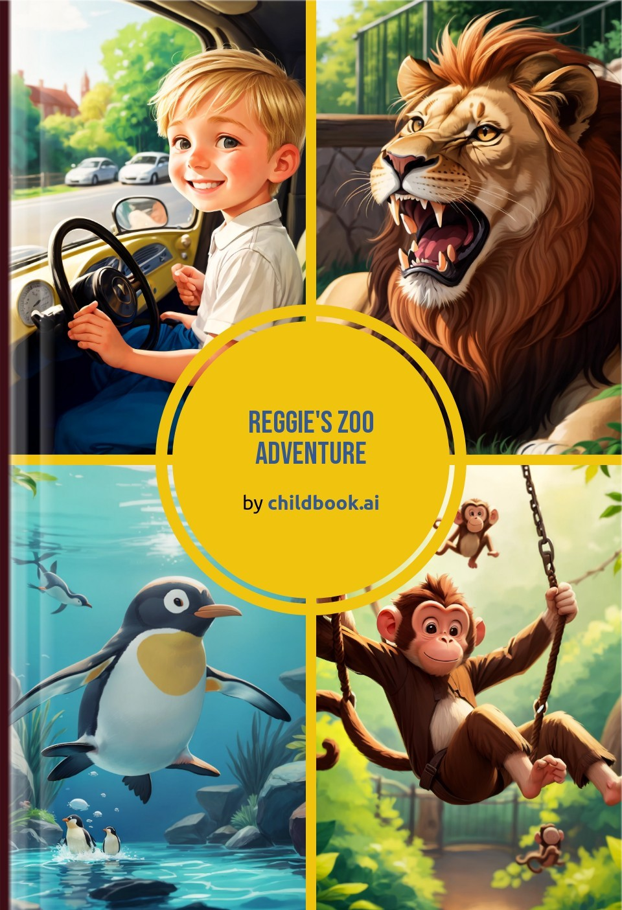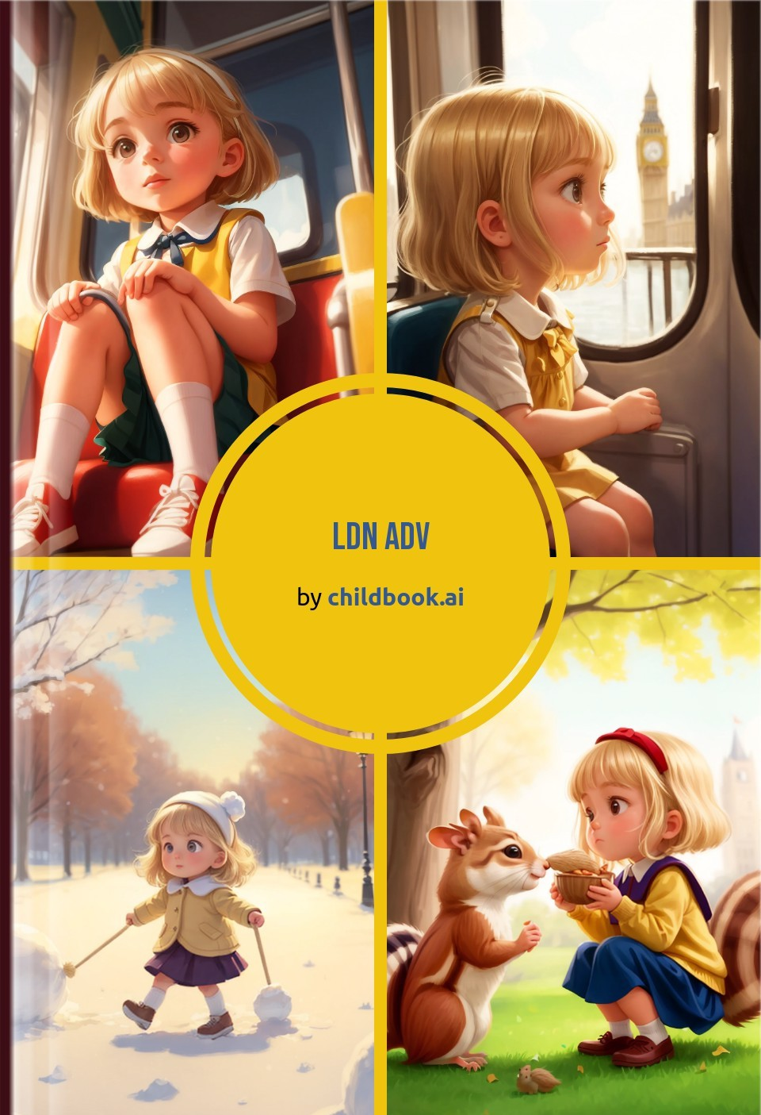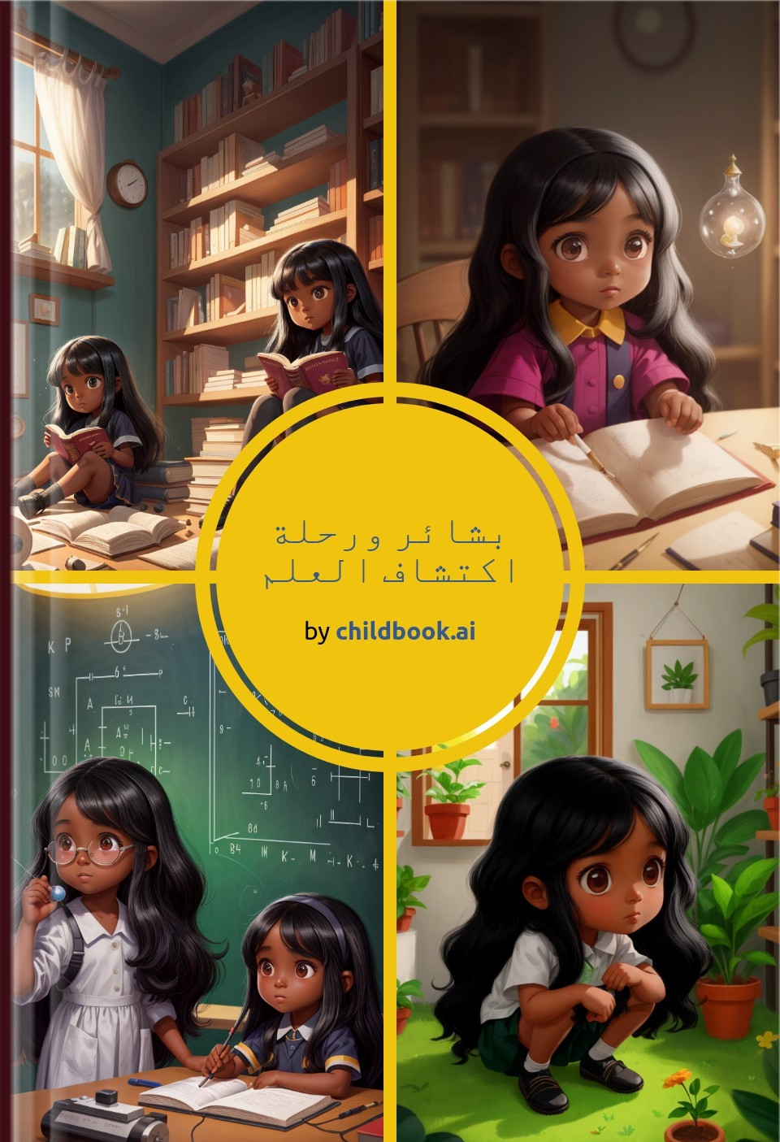

Create a unique children's story with our easy-to-use ai storybook maker. Our personalized children's books are fully customized with original characters, illustrations, and an imaginative plot.